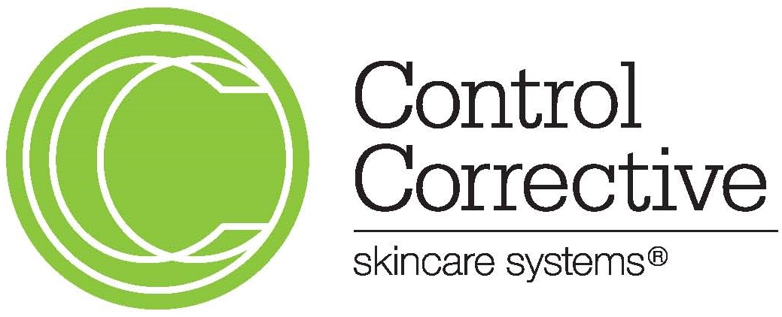

Control Corrective Skincare 10015 Muirlands Blvd Ste C Irvine, CA 92618
T: 1-866-290-4290
www.controlcorrective.com

SAFETY DATA SHEET

SECTION I- PRODUCT AND COMPANY IDENTIFICATION

Product Name: Stem Cell Moisturizer 1oz

Product Code: 094

Product Type: Cream

Emergency Phone Number: 1-949-770-4290

SECTION II- HAZARDS IDENTIFICATION

Emergency Overview
May cause eye irritation

Potential Health Effects: None
Principal Routes of Exposure: Skin Contact

Acute Toxicity
Eyes: May cause irritation.
Skin: Does not pose a potential of skin irritation and sensitization.
Inhalation: No known effect.
Ingestion: No known effect.
Ingestion may cause irritation to mucous membranes.

Chronic Effect: No known effect.

Aggravated Medical Conditions: None known.
Environmental Hazard: See Section 12
for additional ecological information.

Chemical Name | CAS Number | Weight %
S(+)-2-Hydroxypropionnic Acid | 79-33-4 | 0.35 – 0.55 %

SECTION III- COMPOSITION / INFORMATION ON INGREDIENTS

SECTION IV- FIRST AID MEASURES

Eye Contact: Rinse thoroughly with plenty of water, also under the eyelids. If irritation persists, call a physician.
Skin Contact: None under normal use
Inhalation: None under normal use
Ingestion: Rinse mouth with water and afterwards drink plenty of water or milk
Notes to Physician: Treat symptomatically

SECTION V- FIRE FIGHTING MEASURES

Flash Point: Not Applicable
Suitable Extinguishing Media: Use extinguishing measures that are appropriate to local circumstances
and the surrounding environment. Sensitivity to Static Discharge: Not sensitive to static discharge. Protective Equipment and Precaution for Firefighters:
As in any fire, wear self‐contained breathing apparatus pressure‐demand,
MSHA/NIOSH (approved or evaluated) and full protective gear.

NFPA: Health Hazard 1 Flammability 1 Stability 0 Physical and Chemical Hazards 0

SECTION VI- ACCIDENTAL RELEASE MEASURES

Personal Precautions: Avoid contact with eyes.
Environmental Precautions: Prevent entry into waterways, sewers basements, or confined areas.
Do not flush into surface water or sanitary system. Methods for Containment: Prevent further leakage or spillage if safe to do so. Methods for Cleaning Up: Keep in suitable and closed containers for disposal

SECTION VII-HANDLING AND STORAGE

Handling: Handle in accordance with good industrial hygiene and safety practice. Avoid contact with eyes.
Storage: Keep containers tightly closed.

SECTION VIII-EXPOSURE CONTROLS / PERSONAL PROTECTION

Chemical Name | ACGIH TLV | OSHA PEL | NIOSH IDLH
S(+)-2-  Hydroxypropionnic Acid 79-33-4 | No Data | No Data | No Data

Exposure Guidelines

Engineering Measures: Showers, eyewash stations, and ventilation systems.

Personal Protective Equipment

Eye/Face Protection: No special protective equipment required.
Skin and Body Protection: No special protective equipment required.
Respiratory Protection: No protective equipment is needed under normal use conditions
Hygiene Measures: Handle in accordance with good industrial hygiene and safety
practices.

SECTION IX- PHYSICAL AND CHEMICAL PROPERTIES

Physical State: Cream
Color: Off White Odor: Characteristic
pH: 3.5 – 5.0
Flash Point: None Boiling Point/Range: No data available
Melting Point/Range: No data available Specific Gravity: 0.998‐1.020
Solubility: No data available VOC Content (%): Not applicable
Partition Coefficient: n‐octanol/water No data available

SECTION X- STABILITY AND REACTIVITY

Stability: Stable
Incompatible Products: None known.
Conditions to Avoid: Heat, flames and sparks.
Hazardous Decomposition Products: None known
Hazardous Polymerization: Hazardous polymerization does not occur.

SECTION XI- TOXICOLOGICAL INFORMATION

Acute Toxicity
Product Information: Product is safe for its intended use based on the formulation, testing results, and the long history of safe consumer use.

Chronic Toxicity
Chronic Toxicity: No known effect.
Target Organ Effects: None known.

SECTION XII- ECOLOGICAL INFORMATION

Ecotoxicity: The environmental impact of this product has not been fully investigated.

SECTION XIII- DISPOSAL CONSIDERATIONS

Waste Disposal Methods: This material, as supplied, is a not hazardous waste according to federal regulations (40 CFR 261). The material could become hazardous if it is mixed with or otherwise comes into contact with a hazardous waste, if chemical additions are made to this material or if the material is processed or otherwise altered. Consult 40 CFR 251 to determine whether the altered material is a hazardous waste. Consult appropriate state, regional or local regulations for additional requirements.

Contaminated Packaging: Dispose of in accordance with local regulations.

SECTION XIV- TRANSPORT INFORMATION

DOT Not Regulated
TDG Not Regulated
MEX Not Regulated
ICAO Not Regulated
IATA Not Regulated
IMDG/IMO Not Regulated
RID Not Regulated
ADR Not Regulated
ADN Not Regulated

SECTION XV- REGULATORY INFORMATION

U.S. Regulations

SARA 311/312 Hazard Categories

Acute Health Hazard No
Chronic Health Hazard No
Fire Hazard No
Sudden Release of Pressure Hazard No
Reactive Hazard No
California Proposition 65 This product does not contain any Proposition 65 chemicals.

International Regulations

Mexico - Grade Serious risk, Grade 0

WHMIS Hazard Class

Not regulated under CEPA

International Inventories TSCA Exempt
DSL Complies

Legend
TSCA - United States Toxic Substances Control Act Section 8(b) Inventory
DSL/NDSL - Canadian Domestic Substances List/Non-Domestic Substances List

SECTION XVI- OTHER INFORMATION

Prepared By Control Corrective Skincare
10015 Muirlands Blvd. Suite C
Irvine, CA 92618
T: 1-866-290-4290
http://www.controlcorrective.com

Revision Date September 21, 2015

Disclaimer
The information provided on this MSDS is correct to the best of our knowledge, information and belief at the date of its publication. The Information given is designed only as a guide for safe handling, use, processing, storage, transportation, disposal and release and is not to be considered as a warranty or quality specification. The information relates only to the specific material designated and may not be valid for such material used in combination with any other material or in any process, unless specified in the text.

The information above is believed to be accurate and represents the best information currently available to us. However, we make no warranty of merchantability or any other warranty, express or implied, with respect to such information, and we assume no liability resulting from its use. Users should make their own investigations to determine the suitability of the information for their particular purposes. In no event shall Control Corrective Skincare be liable for any claims, losses, or damages of any third party or for lost profits or any special, indirect, incidental, consequential or exemplary damages, howsoever arising, even if Control Corrective Skincare has been advised of the possibility of such damages.

